# PROJECT SCREENSHOT

# 2022 SCORE AND 5 YEAR GDP GROUP:

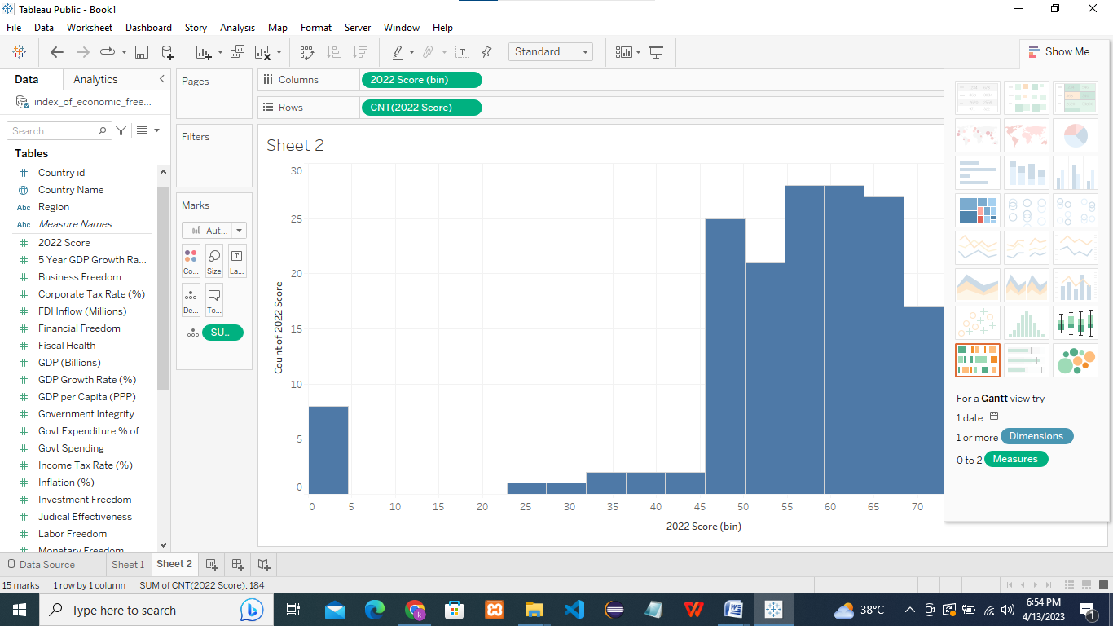

GDP PER CAPITA AND GDP GROWTH RATE:

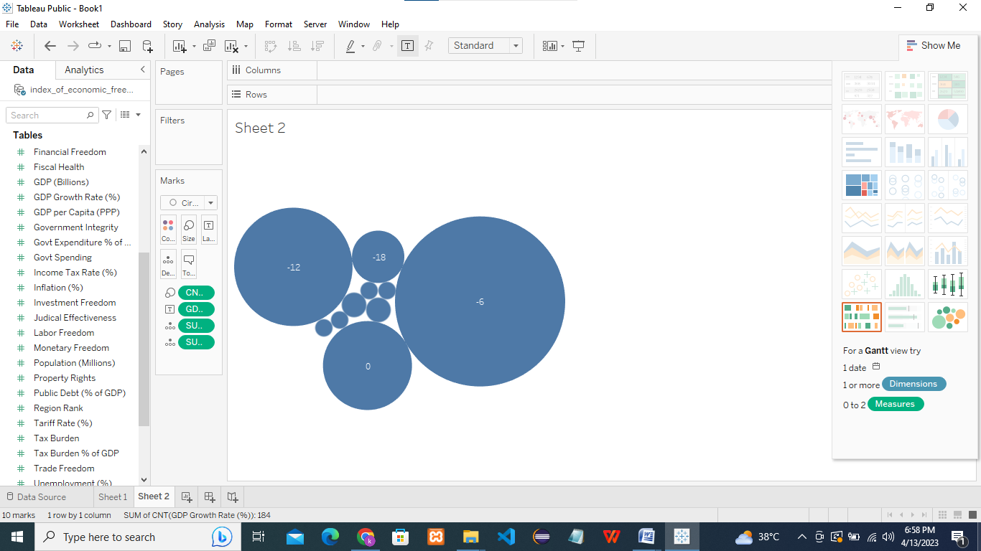

INFLATION AND INCOME TAX RATE:

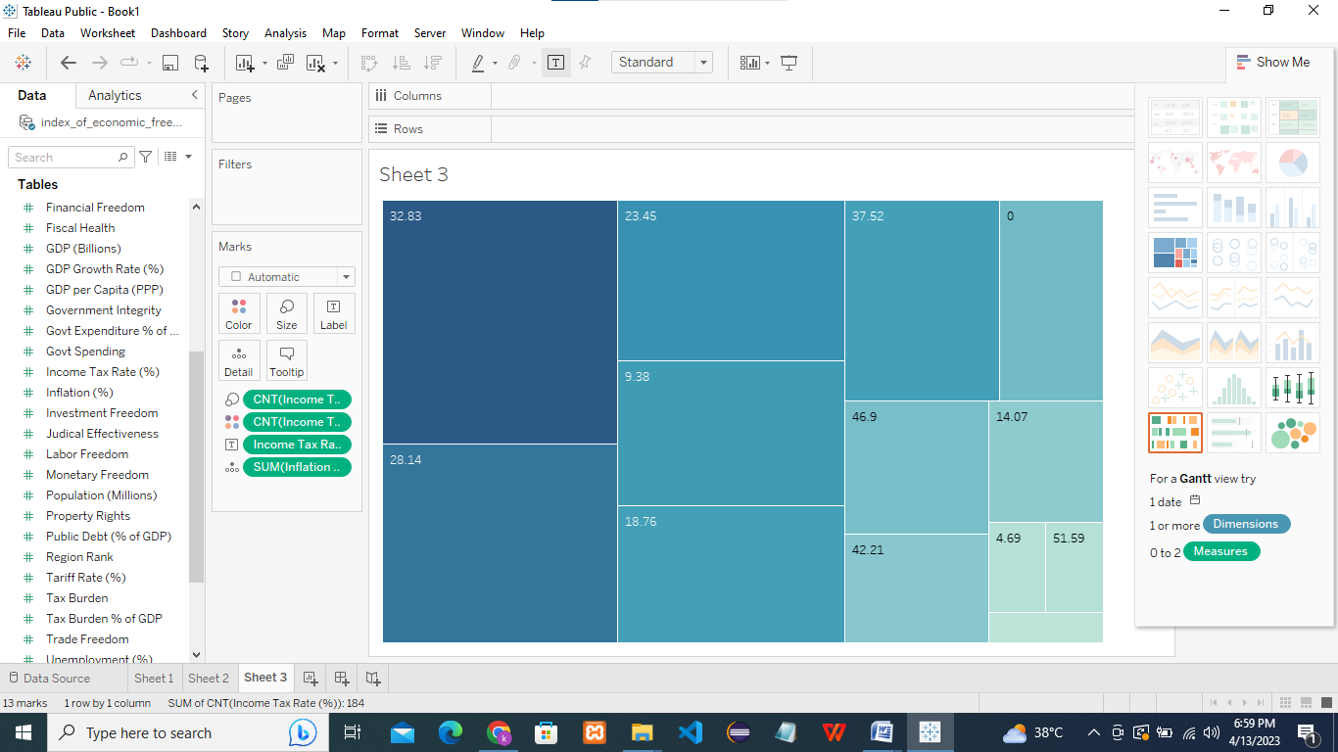

TAX BURDER % OF GDP AND TAX BURDEN:

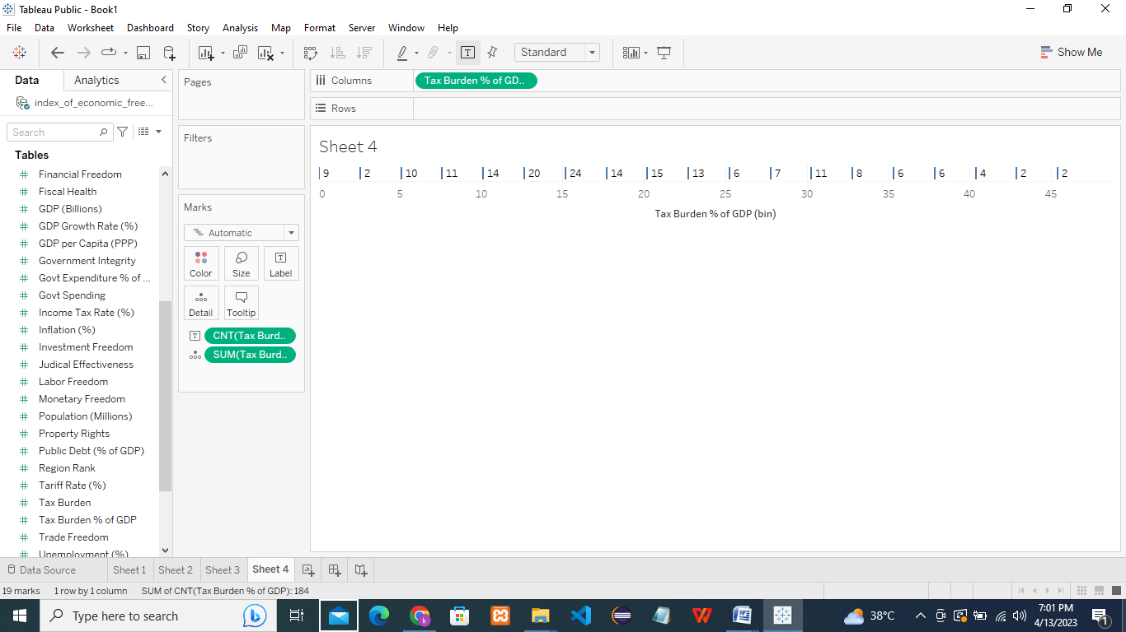

UNEMPLOYMENT AND TRADE FREEDOM:

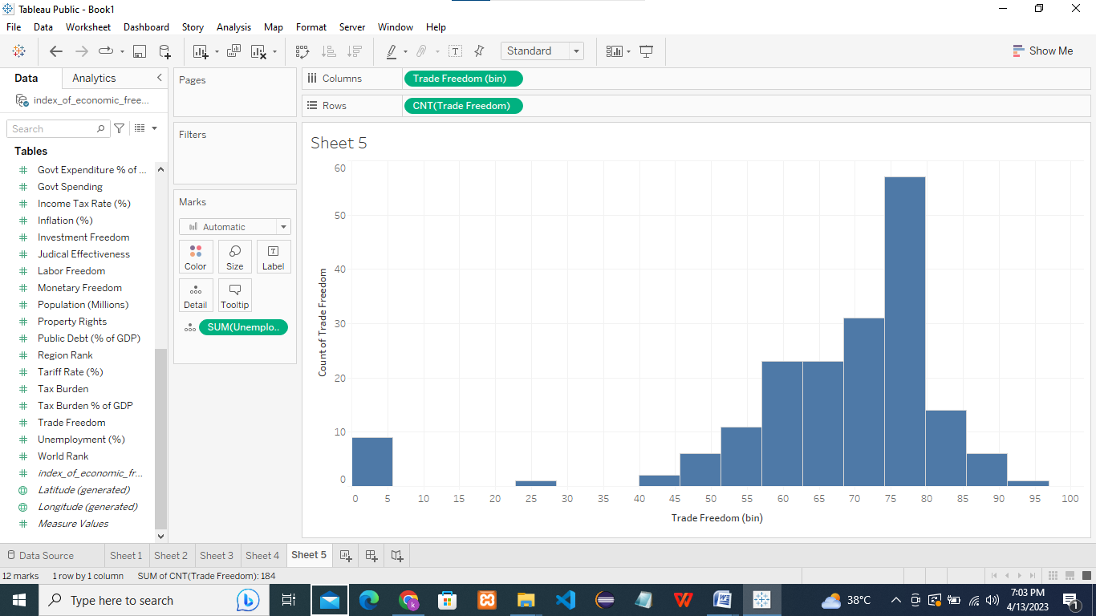

GOVERNMENT EXPENDITURE AND GOVERNMENT SPENDING:

